UNIVERSITY OF MINNESOTA

Duluth Campus Department of Studies in Justice, Culture, and Social Change 228 Cina Hall
College of Arts, Humanities, and Social Sciences 1123 University Drive
Duluth, Minnesota 55812-3306
E-mail: troufs@d.umn.edu
ZOOM: https://umn.zoom.us/my/troufs
13 October 2024





f2024 Week 8 Module



Tim Roufs, Singapore Market, 2017

Anthropology of Europe Week 8

What’s Happening Week 8?

        - READ AND WATCH
          - READ TEXT . . .
          - VIEW SLIDES
          - WATCH VIDEO
            - Watch Video Clips
          - IN-THE-NEWS
        - MIDTERM EXAM
        - DISCUSSION
        - PROJECT
        - OTHER
            - EXTRA CREDIT
            - FOR FUN TRIVIA (optional)
            - LIVE CHAT (optional)
Tuesday 7:00-8:00 p.m.
        - QUESTIONS / COMMENTS / SUGGESTIONS
        - WRAP-UP
[click ↑ here]

What’s Happening Week 8?

This week take a little time to go over your Midterm exam—with an eye on the Final Exam. Going over the Midterm oftentimes helps when it comes to preparing for the Final Exam. If you have any questions or comments please let me know.

Ireland

This week we’re headed off to the Emerald Isle, one of the most beautiful places on earth. Our introduction to Ireland, as it was for Greece, is with one of the great classic films of all times, Robert Flaherty’s Man of Aran. Then, in one of the unique events in ethnocinematography, we’ll spend an hour visiting years after with the locals who were featured in Man of Aran, as well as their neighbors who are not so famous. In "How the Myth was Made" we have a retrospective look at Flaherty’s work, and let the locals explain its meaning.

And we follow up these classic videos with slide decks featuring . . .
- the Aran Islands, off the coast of Galway,
- the western and southern coasts around (a) The Dingle Peninsula, (b) The Ring of Kerry—home of the famed Kerrymen—and (c) Cork—usually the main town on your way to kiss the Blarney Stone at the Blarney Castle, and
- Newgrange—a site like Stonehenge only a thousand years older than Stonehenge, and five hundred years older than the great pyramid of Giza in Egypt.

And finally, schedule in some time blocks to work on your Project, after you complete a brief Student Survey.

Read and Watch Week 8

READ THE TEXTBOOK FOR WEEK 8
Textbook Information
Readings for the Semester

REM: Links on screenshots are not “hot” (active)
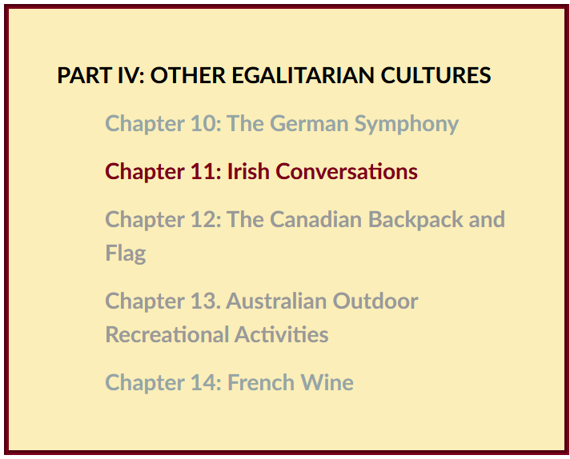f

VIEW THE SLIDES FOR WEEK 8
Class Slides for the Semester

Ireland: Introduction / Inis Oírr
(aka Inish Beag)
(.pptx)
[click ↑ here]

Ireland: Aran, Galway, Clare, Conamara
(aka Inish Beag)
(.pptx)
[click ↑ here]

Ireland: Dingle, Kerry, Bantry, Cork . . .
(.pptx)
[click ↑ here]

Ireland: Newgrange
(.pptx)
[click ↑ here]

Slán agat IRELAND

We’ll finish our Ireland materials with the slides from Inish Óirr (aka Inish Beag), the smallest of the three well-known Aran Islands. We’ll visit the knitters of the famous “Irish Fisherman Sweaters”, and have a look around the island, and “the mainland”, before we have a brief look at Newgrange and say Slán agat.

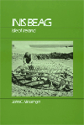

The full Ireland slide sequence,
should you want to look at the other slides, includes . . . .

- Introduction / Inis Oírr slides: (.pptx)
- Aran, Galway, Clare, Conamara . . . slides: (.pptx)
- Dingle, Kerry, Bantry, Cork . . . slides: (.pptx)
- Dublin . . . slides: (.pptx)
- Newgrange . . . slides: (.pptx)
- Analysis . . . slides: (.pptx)


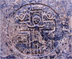

Inish Óirr
Ireland

WATCH THE VIDEO EXPLORATIONS FOR WEEK 8
Real People . . . Real Places . . .
Videos for the Semester

Ireland

One of the great films of all time is Robert Flaherty’s Man of Aran. It’s a classic, from just this side of silent movie days. Man of Aran is also a “Master Text” for Ireland and for Anthropology of Europe as a whole. Man of Aran did almost all of those things “Master Texts” and “Classics” are supposed to do—including create lasting images that become the popular conceptions of a people, and it formulated the people as myth.

We’ll first have a look at Man of Aran, and then we’ll listen to what the Aran Island people have to say about “their” iconic film. Some of the very same people who “starred” in Man of Aran—will tell you what they think, in “How the Myth Was Made”.

And after we’ve had a chance to see Man of Aran and How the Myth Was Made this week, we’ll take a walk around Inis Óirr (Inish Beag to John C. Messenger) and many other parts of the Emerald Isle after Spring Break.

First we’ll have a look at Robert Flaherty’s Film Classic, and Master Text

Man of Aran
(77 min, 1934, B&W)

Ireland

One of the great films of all time is Robert Flaherty’s Man of Aran. It’s a classic, from just this side of silent movie days. Man of Aran is also a “Master Text” for Ireland and for Anthropology of Europe as a whole. Man of Aran did almost all of those things “Master Texts” and “Classics” are supposed to do—including create lasting images that become the popular conceptions of a people, and it formulated the people as myth.

We’ll first have a look at Man of Aran, and then we’ll listen to what the Aran Island people have to say about “their” iconic film. Some of the very same people who “starred” in Man of Aran—will tell you what they think, in ”How the Myth Was Made”.

And after we’ve had a chance to see Man of Aran and How the Myth Was Made this week, we’ll take a walk around Inis Óirr (Inish Beag to John C. Messenger) and many other parts of the Emerald Isle after Spring Break.

First we’ll have a look at Robert Flaherty’s Film Classic, and Master Text

Man of Aran
(77 min, 1934, B&W)

on-line access
[click ↑ here]
Alexander Street

New UMD Link for Man of Aran
via AVON 2023.05.12

New UMD Link for Man of Aran
old link expires 12/07/2023

course viewing guide

Aran Islands, Ireland

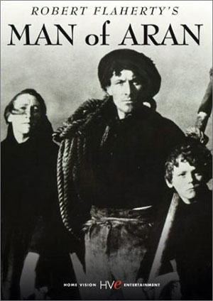

(UM Duluth Martin Library Multimedia DA990.A8 M37 2003 DVD)

Man of Aran created lasting images and formulated the insular people of Ireland as a popular myth.

What do the people of the Aran Islands think about that?

We’ll see about that in

"How the Myth was Made"
(60 min, 1978)

on-line access
[click ↑ here]
Alexander Street

viewing guide

(UM Duluth Martin Library Multimedia DA990.A8 M37 2003 DVD)

“. . . The work of anthropologists is not only to invent, explore, and make useful the general concept of ‘culture’ but also to invent particular cultures”

-- Roy Wagner (1975), quoted in Susan Parman,
Europe in the Anthropological Imagination (1998), p. 2

"How the Myth was Made" is a sixty minute documentary about the making of Man of Aran, where you will see the actors themselves reflect on the film, and find out what their neighbors think about it.

A little later we’ll visit Inish Óirr (aka Inish Beag), the smallest of the three Aran Islands. We’ll visit the knitters of the famous “Irish Fisherman Sweaters”, and have a look around the island, and “the mainland”, before we say Slán agat.

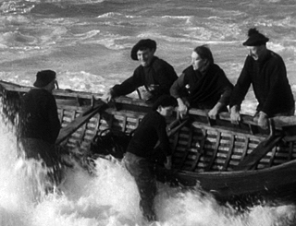

Scene from Man of Aran

WATCH THE VIDEO CLIPS FOR WEEK 8

Watch Video Clip
Class Slides for the Semester

IN-THE-NEWS WEEK 8
Media Bias Chart
Fake News

Sign Up in your Course Google Drive Folder:
f2024 <https://docs.google.com/document/d/1IlkUMRHy7ZPeIbxYelRuFGw4Vc5ZwXwv1e-qKEgDDvk/edit?usp=sharing>
[click ↑ here]

REM: "Fake News"? / Media Bias? / "Alternative Facts"? (Helpful Chart)

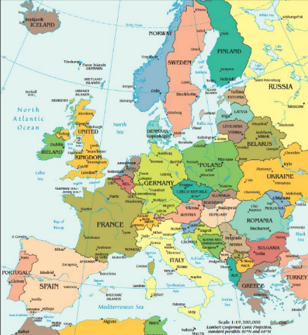

Ireland – tba

MIDTERM EXAM . . .
General Midterm Exam Information

Brief Review of Midterm Exam

If you took the exam, check for the results are in your Gradebook (check the left-hand Course Navigation column on your “Home” page).

Then take a little time to go over your Midterm exam—with an eye on the Final Exam. Going over the Midterm oftentimes helps when it comes to preparing for the Final Exam. If you have any questions or comments please let me know.

REM: Links on screenshots are not “hot” (active)


Set your “Arrange By” preferences in your Gradebook:

REM: Links on screenshots are not “hot” (active)
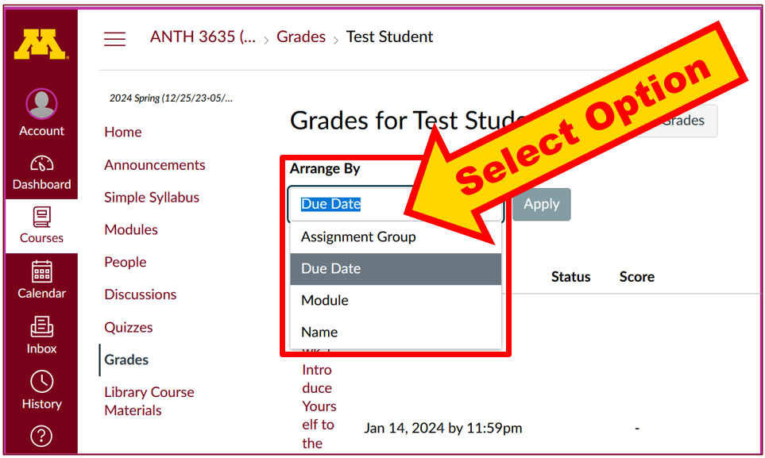

Profs “grading” exams is a lot like an ump in Major League Baseball calling balls and strikes. The Major League rules are clear <http://www.d.umn.edu/cla/faculty/troufs/anth3635/cegrades.html#strikezone> as are the stated criteria for written projects and exams <http://www.d.umn.edu/cla/faculty/troufs/anth3635/cegrades.html#title>.

But, in the end, they are both human judgments.

The biggest difference between a Major League Umpire calling balls and strikes and a professor calling a grade is that you jet ejected from the baseball game if you are argue balls and strikes (see Section 9.02 Official Baseball Rules <http://mlb.mlb.com/mlb/official_info/official_rules/foreword.jsp> and one should really question the prof if they didn’t like the call, and that is especially true for midterm exams as one can often learn quite a bit that is helpful for the Final Exam by looking over and discussing a midterm exam.

Maybe a better analogy would be judging Olympic Figure Skating, or Gymnastics, or Ski Jumping, Diving and the like . . . <http://www.d.umn.edu/cla/faculty/troufs/anth3635/cegrades.html#gymnastics>.



If your style is to look at charts, the grading “chart” is at<http://www.d.umn.edu/cla/faculty/troufs/anth3635/cegrades.html#gradingpolicies>.

So if, for whatever reason, you didn’t like “the call,” e-mail.

Please pay attention to what the numbers mean in terms of the final course letter grade. Click “View Rubric” on the exam page for details.

REM: Links on screenshots are not “hot” (active)

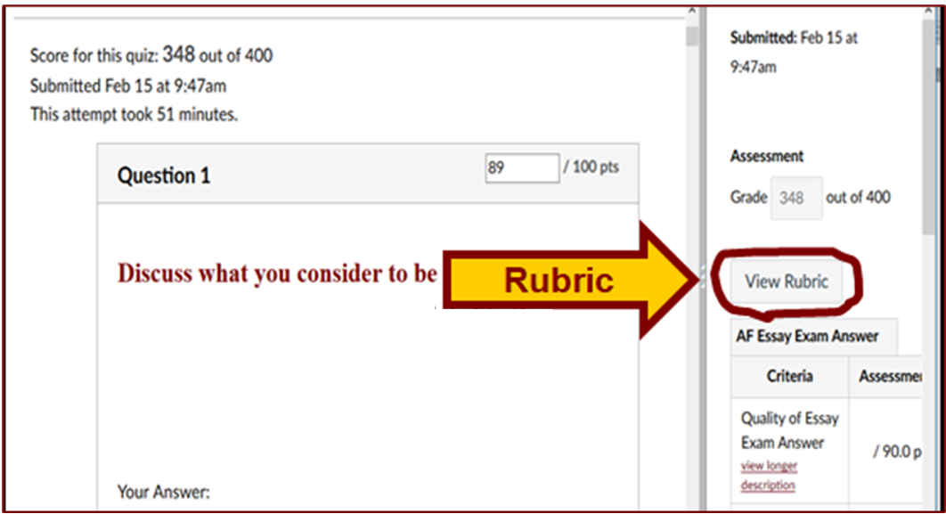

DISCUSSION FOR WEEK 8
Online Discussions Information, Rubric, and Sample Posts

PROJECT INFORMATION . . .
Basic Information
Main Due Dates

Schedule Some Time Blocks to Work on Your Class Project

Project Time Blocks

If you haven’t already done so, schedule some serious time blocks to work on your Project. And be sure to ask if you have any questions about your Promissory Abstract, your Working Bibliography, or even about your Proposal itself.

One thing you should already have started to think about is how you might present your findings. Generally it is a good idea to pretty much finish your paper before you do too much work on your presentation, but, having said that, it is still a good idea to at least start thinking about what your presentation might be like.

OTHER . . .
Main Due Dates

f2024 Module Week 8

(optional) Study Abroad? Explore the World? Do it. . . .

Take the Student Survey

For this week our course developer, has prepared an on-line survey of the class. Please help us by filling it out honestly, and promptly. Your views are very important in the future development of this course. The survey is part of our main “Assignments and Activities” of the week . . .

Student Survey Feedback
f2024 <https://canvas.umn.edu/courses/450740/modules/items/12194495>
[click ↑ here]

REM: Links on screenshots are not “hot” (active)
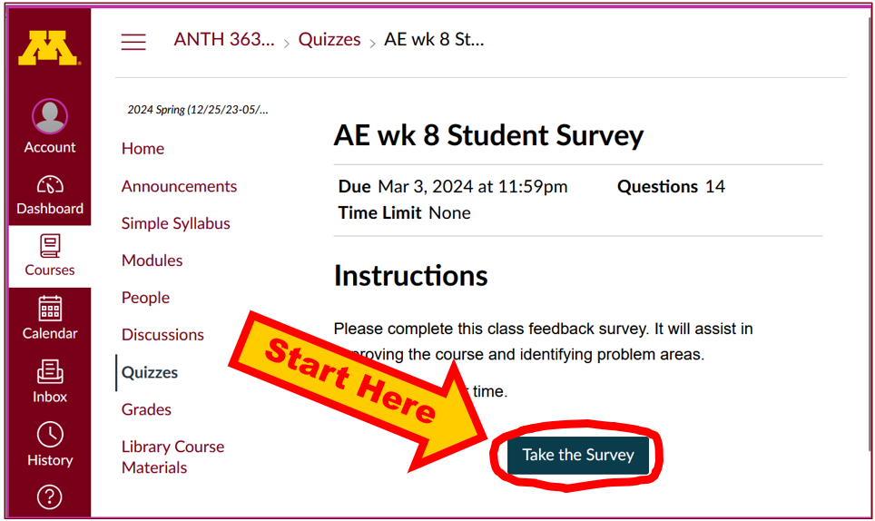

Review . . .

Writing Essays for Exams

If you have any questions about the Final Exam, please let me know, or bring them up in.

(optional) EXTRA CREDIT . . .
Basic Extra Credit Information

Extra Credit is available in this class.
We’ll have a closer look at Extra Credit after the Midterm Exam.

Be sure to check the details of the activities and assignments each week in your folder.

If you didn’t do quite as well as you might have liked on the Midterm Exam, or if you did better than you even hoped on the Midterm exam but want to “bank” some insurance points for your final course grade, think about doing one (or even two—one of each) of the optional extra credit papers.

There are two Extra Credit options: (A) a case study, and/or (B) a review of a lecture or event, or an approved film (other than one of the films we see in class). For the review option you may also compare two or more films. (Remember from Week 1, one of the main features of anthropology is that it is comparative?)

Details on the extra credit are on-line at
<http://www.d.umn.edu/cla/faculty/troufs/anth3635/extra_credit/ceextracredit.html#title>

FOR FUN TRIVIA (optional)
Food Trivia HomePage

LIVE CHAT OPEN FORUM / OFFICE HOURS . . . (optional)
Tuesday 7:00-8:00 p.m. (CDT) On ZOOM
Contact Information
“ZOOM”
[click ↑ here]
or
e-mail anytime: mailto:troufs@d.umn.edu
[click ↑ here]

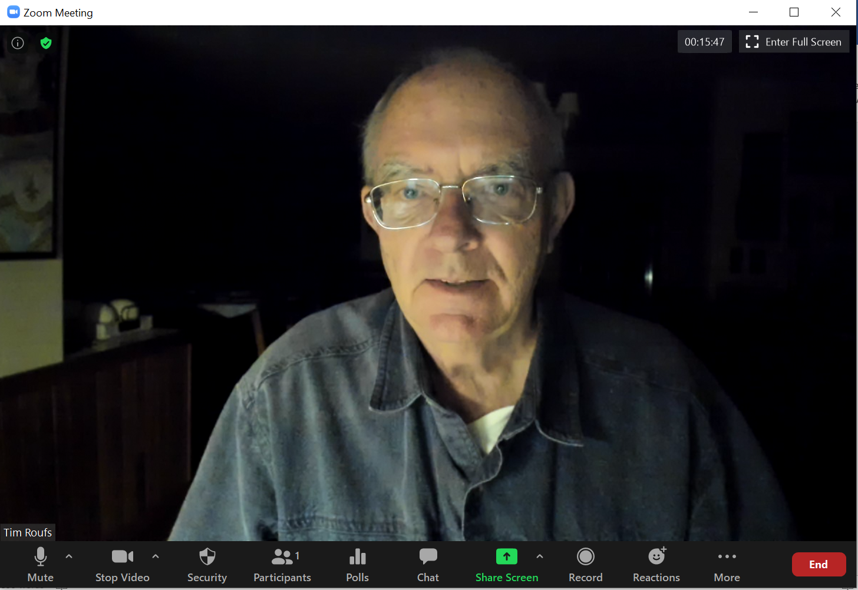

Live Chat is optional.

QUESTIONS? / COMMENTS / SUGGESTIONS . . .

If you have any questions or comments right now, please do not hesitate to post them on the “Discussions”, or e-mail troufs@d.umn.edu, or ZOOM https://umn.zoom.us/my/troufs. (E-mail is fastest, and most generally best as quite often URLs need be sent.)

Best Wishes,

Tim Roufs

<http://www.d.umn.edu/~troufs/>
<https://umn.zoom.us/my/troufs>
<other contact information>

